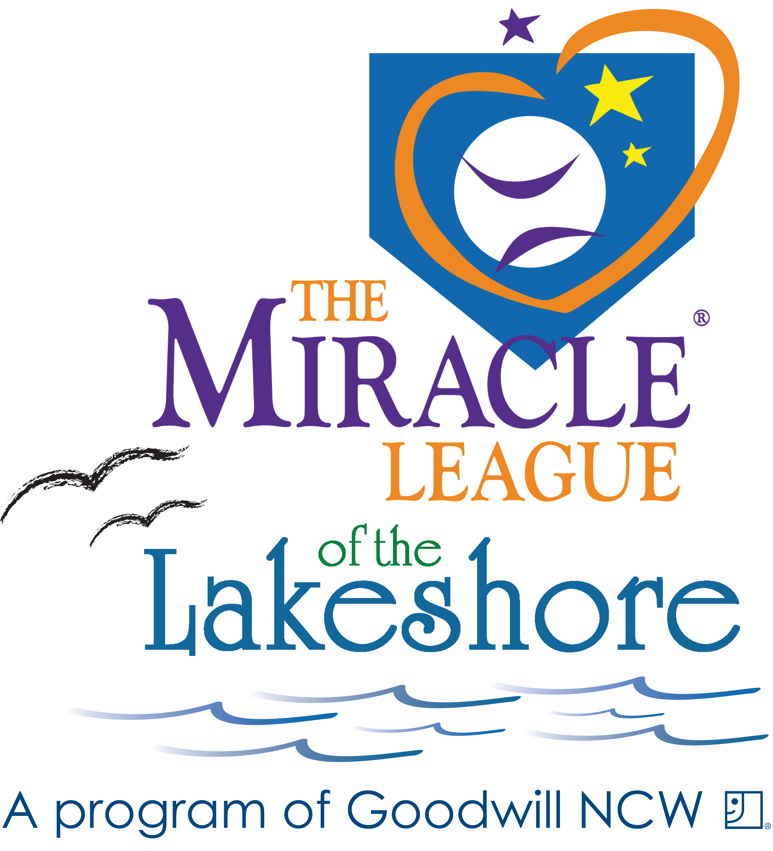
Miracle League of the Lakeshore
2019 Season PLAYER Registration
Registration February 2019- April 1, 2019

The Miracle League of the Lakeshore is an organized baseball league for children ages 4-19 with cognitive and/or physical disabilities. Players will be notified of their team mid-April 2019
A mandatory League meeting will be scheduled at the end of May. Opening Day will be June 1, 2019.

Games are played on Monday- Thursday evenings at 5:30pm or 7pm. Each player will play only one game a week. Currently we play Monday’s or Thursday’s, however depending on the number of registrations we receive, we may add Tuesday’s. Schedules are sent out at the end of April.
Registration deadline is April 1, 2019.
Please print legibly and fill out front &back of form.

Player Name_______________________________________________________________ Nickname_________________________________

(circle one) Male / Female DOB ______________ Age as of June 1, 2019_______ School________________________________________

Parent(s)/Guardian(s) Name______________________________________________________________________________________________

Address__________________________________________________________City, State, Zip________________________________________

Phone # ________________________________________________Cell#_________________________________________________________

Email Address____________________________________________ Emergency Contact and Phone #__________________________________

This is my first year playing Miracle League baseball: YES/NO If no, team name from last year and where _________________________________
In the best interest of the player, a parent/guardian must be on site during the player’s baseball game -- this is not a drop off league.

Player Shirt Size (circle one) YOUTH: S M L XL OR ADULT: S M L XL 2XL 3XL.
If the wrong shirt size is ordered, a $20 fee will be charged for a replacement.

Please tell us about your child. You know your child best and we use this information to help pair your child with a buddy. Thank you! Please provide specifics

Diagnosis_______________________________________________________________________________________________________________

Also include any information that will support the success of your child: special needs, requirements, schedule requests or team requests:

_______________________________________________________________________________________________________________________

_______________________________________________________________________________________________________________________

_______________________________________________________________________________________________________________________

What is your favorite song? __________________________________________________
Is your child left handed or right handed? ___________
What are you expecting to gain from the league? ________________________________________________________________________________

My child is (pls. check) Verbal___ Non-Verbal___ My child uses: (pls.check) wheelchair___ walker____ other ___________________________

*** Volunteer Buddy INFORMATION ***
Does your child prefer a male or female volunteer? _______________
______ I would like the Miracle League to provide a buddy to be on the field with my child. Which type of Buddy would be best for your child? (circle one) Adult Young Adult Teen

______ I will be providing my child’s own buddy. Name of volunteer buddy is________________________________________________________
Just a reminder, volunteers need to fill out registration form, too.

______ I would like my buddy from last year - Name of volunteer buddy_____________________________________________________________
Just a reminder, volunteers need to fill out registration form, too.

How did you hear about the Miracle League of the Lakeshore? ___________________________________________________________________

I give authorization for my above-named to participate in the Miracle League of the Lakeshore. I know that participation in baseball may result in serious injuries, and protective equipment does not prevent all injuries to players, and I do hereby waive, release, absolve, indemnify, and agree to hold harmless the Miracle League of the Lakeshore, Goodwill NCW, and the City of Appleton, their organizers, sponsors, agents, insurers, supervisors, participants, and volunteers, from any claim arising out of any injury to my/our child whether the result of negligence or for any other cause.

I hereby grant the Miracle League of the Lakeshore, its affiliates, franchises, advertising, and promotional agencies, and their agents, the irrevocable,
unrestricted right to use, publish, display and distribute materials bearing my name, voice, likeness or any other identifiable representation of myself,
my family members including my Miracle League player/child. These materials may appear in any form, style, color or medium whatsoever
(including, without limitation, photographs, video tapes, films, sound recordings, software, drawings, prints, broadcast, internet and electronic
media). I agree that all material containing any identifiable representation of me (including without limitation, all negatives, plates and masters of
any photographs, files, prints or tapes) shall be and remain the sole and exclusive property of the Miracle League of the Lakeshore.

I hereby release and forever discharge the Miracle League of the Lakeshore from any and all liability and damages relating to the use of my name, voice, likeness or any other identifiable representation of me. I hereby waive any right I may have to inspect or approve the finished materials or any part or element thereof that incorporate my name, voice, likeness or any other identifiable representation of myself, my family including, my Miracle League player/child.

By signing below, I acknowledge that I have fully read and understand this document and I have had questions regarding its effect or the meaning of its terms answered to my satisfaction. I certify that I am at least 18 years of age, unless this document is also signed by my parent or legal guardian.

Signature of Parent/Guardian: ____________________________________________________________________ Date: ___________________

Printed Name of Parent/Guardian: _________________________________________________________________________________________

Registration Fee:
$45/player ($5 discount for multiple family members)
If registering after April 1, 2019, there will be a $15 dollar fee added to your registration fee.

Player scholarships are available. Please request scholarship form via miracleleaguelakeshore@yahoo.com

Please consider making a donation to support the Miracle League of the Lakeshore Player Scholarship Fund

___$5 ___$10 ___$15 ___$20 ___other___

Please make all checks payable to: GOODWILL/MLL

Mail completed form & registration fee to: Laura Ziemer, PO Box 232, Manitowoc, WI 54221

CONTACT US:
Email registration questions: miracleleaguelakeshore@yahoo.com
Web: www. miracleleaguelakeshore.com
Find us on Facebook: www.facebook.com/miracleleagueofthelakeshore

