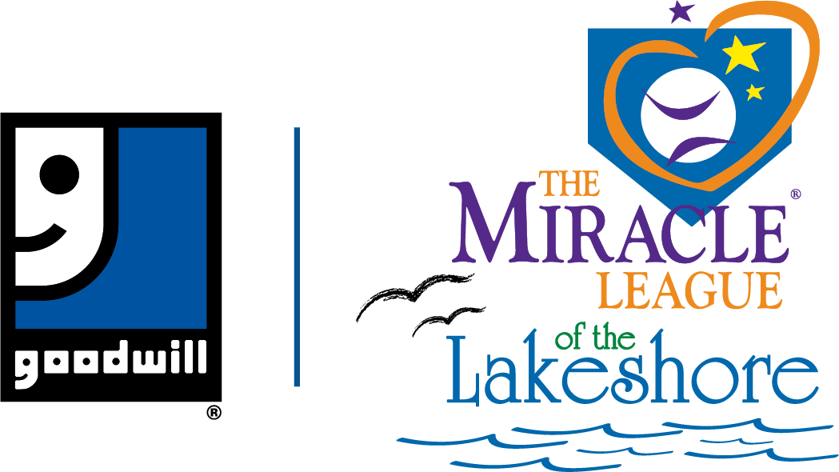

Miracle League of the Lakeshore
Over 19 League Volunteer Registration Form
2021 Season

The Miracle League of the Lakeshore, a program of Goodwill NCW, is an organized baseball league for children ages 4-19 with intellectual and/or physical disabilities. Games are played at the accessible Goodwill NCW Miracle League Field of Dreams facility at Miracles Park, Manitowoc. Volunteers will be notified of their teams in May. The season will begin the week of June 7th.

To guarantee a 1:1 player match – complete form, mail or scan & email by May 17, 2021.
Please fill out the front and back of this form and please print legibly.

Volunteer Opportunity (please select one):
☐ volunteer buddy (buddy needs to be 18 years of age as of June 1, 2021)
☐ umpire (must be at least 21 years old)
☐ coach (must be at least 21 years old)

A volunteer buddy is paired with a player for the entire season and is expected to attend all the player’s games during the summer baseball season.

Please note that any volunteer over the age of 18, no matter the relation to the player, must complete a background check. These checks are completed to protect our participants and no exceptions will be made. If a background check isn’t completed, a volunteer cannot participate. Background checks will be emailed to the volunteers based on the email address from their registration form.

Name________________________________________________________________ DOB__________________ Age_____________

Address______________________________________________________City, State, Zip______________________________________

Phone # ____________________________________________Cell#_______________________________________________________

Email Address_____________________________________________________ Shirt Size (circle one) Adult: S M L XL 2XL 3XL

I was community volunteer in the 2019 season:
☐ No
☐ Yes, If yes, team or coach’s name in 2019: ___________________________________________________

I would like to be a volunteer buddy for (name of player):___________________________________

This will be my 1st ☐ 2nd ☐ 3rd year as a volunteer

Please list qualifications, team requests, player’s requests, game night requests or other information that you feel are important to matching you with a Miracle League player.

How did you hear about the Miracle League? _________________________________________________________________________

Please list any community organizations, clubs or team sports that you are involved with:

________________________________________________________________________________________________________________________

I have _____years of experience with: ☐ youth sports ☐ baseball ☐ individuals with disabilities

If you are a student, what school do you attend?________________________________________________________________________

In consideration for the Miracle League of the Lakeshore providing the opportunity for me to participate in Miracle League baseball, the undersigned does hereby release and agree to indemnify and hold harmless Goodwill NCW, the City of Manitowoc, Miracle League of the Lakeshore and its officers and directors from any and all claims for personal injury, death, property damage, or any type of claim or damage (including but not limited to attorney's fees or litigation expenses) resulting from my activities in connection with participation in Miracle League baseball or the participation of any family member or guest of the undersigned. I assume all risks and hazards incidental to such participation in Miracle League games and activities and consent for me to receive first-aid and/or emergency care by a qualified Emergency Medical Technician or physician or other person qualified to render medical assistance in the event I suffer an injury during sanctioned games and activities.
I understand that there will be media and promotional coverage of Miracle League games and activities and I give my consent to publish my name and picture for such purposes. I hereby grant the Miracle League of the Lakeshore, its affiliates, franchises, advertising and promotional agencies, and their agents, the irrevocable, unrestricted right to use, publish, display and distribute materials bearing my name, voice, likeness or any other identifiable representation of myself and my family members. These materials may appear in any form, style, color or medium whatsoever (including, without limitation, photographs, video tapes, films, sound recordings, software, drawings, prints, broadcast, internet and social media). I agree that all material containing identifiable representation of me (including without limitation, all negatives, plates and masters of any photographs, files, prints or tapes) shall be and remain the sole and exclusive property of the Miracle League of the Lakeshore.
I hereby release and forever discharge the Miracle League of the Lakeshore from any and all liability and damages relating to my name, voice, likeness or any
identifiable representation of me. I hereby waive any right I may have to inspect or approve the finished materials or any part or element thereof that incorporates my name, voice, likeness or any other identifiable representation of myself and my family. I have agreed to the above in consideration of the opportunity given to me by the Miracle League of the Lakeshore to appear in these materials.

By signing this form, Goodwill NCW is authorized to perform a background check on the volunteer participant.
I acknowledge that I have fully read and understand this document and I have had questions regarding its affect, or the meaning of its terms answered to my satisfaction. I certify that I am at least 18 years of age, unless this document is also signed by my parent or legal guardian.

Volunteer Signature: ________________________________________________________________ Date: _________________________________

Signature of Parent/Guardian (if under 18)_______________________________________________ Date: _________________________________

Printed Name of Parent/Guardian:__________________________________________________________________________________________

Mail completed form & registration fee to:
Miracle League of the Lakeshore
ATTN: Laura Ziemer
PO BOX 232
Manitowoc, WI 54221

miracleleaguelakeshore@yahoo.com
www.miracleleaguelakeshore.com
www.facebook.com/miracleleaguelakeshore

