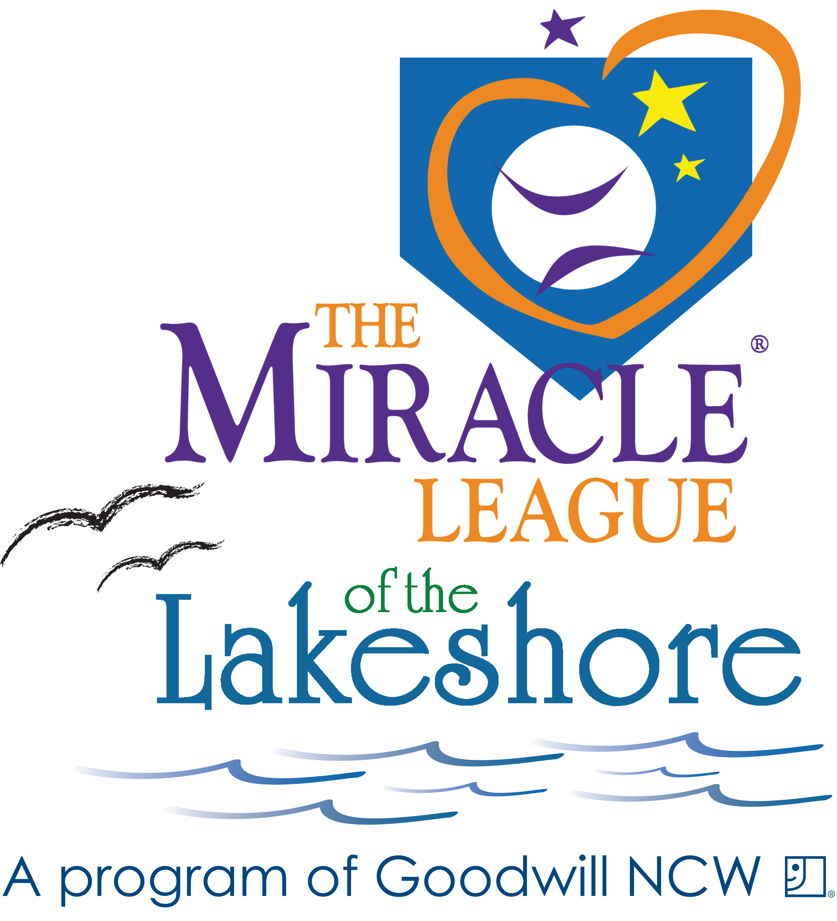
All Star Miracle League
2020 Season PLAYER Registration
Registration February 2020- April 1, 2020

The All Star League is a non competitive organized baseball league for adults with cognitive and/or physical disabilities. Players will be notified of their team early May 2020
A mandatory League meeting will be scheduled on May 17th. Opening Week will be June 10,2020.

Games are played on Wednesday Evenings at 6 p.m. Each player will play only one game a week.
Registration deadline is April 1, 2020
Please print legibly and fill out front &back of form.

Player Name_______________________________________________________________ Nickname_________________________________

(circle one) Male / Female DOB ______________ Age as of June 1, 2020_______ School________________________________________

Parent(s)/Guardian(s) Name______________________________________________________________________________________________

Address__________________________________________________________City, State, Zip________________________________________

Phone # ________________________________________________Cell#_________________________________________________________

Email Address____________________________________________ Emergency Contact and Phone #__________________________________

This is my first year playing League baseball: YES/NO If no, team name from last year and where _________________________________
We appreciate if guardians will stay for the games in case of emergencies.

Player Shirt Size (circle one) YOUTH: S M L XL
ADULT: S M L XL 2XL 3XL.
If the wrong shirt size is ordered, a $20 fee will be charged for a replacement.

Please tell us about yourself. We use this information to help pair you with a buddy. Thank you! Please provide specifics

Diagnosis_______________________________________________________________________________________________________________

Also include any information that will support the success on the field: special needs, requirements, schedule requests or team requests:

_______________________________________________________________________________________________________________________

_______________________________________________________________________________________________________________________

_______________________________________________________________________________________________________________________

I am right handed or left handed? ___________
What are you expecting to gain from the league? ________________________________________________________________________________

I am (pls. check) Verbal___ Non-Verbal___ I Use: (pls.check) wheelchair___ walker____ other ___________________________

*** Volunteer Buddy INFORMATION *** (A buddy is not required if you choose not to have one.)
I would prefer a buddy: ________yes or ____________no
Doe you prefer a male or female volunteer? _______________

______ I would like the All Star League to provide a buddy to be on the field with me. .
______ I will be providing my own buddy. Name of volunteer buddy is________________________________________________________
Just a reminder, volunteers need to fill out registration form, too.

How did you hear about the All Star League? ___________________________________________________________________

I give authorization for my above-named to participate in the Miracle League of the Lakeshore. I know that participation in baseball may result in serious injuries, and protective equipment does not prevent all injuries to players, and I do hereby waive, release, absolve, indemnify, and agree to hold harmless the Miracle League of the Lakeshore, Goodwill NCW, and the City of Appleton, their organizers, sponsors, agents, insurers, supervisors, participants, and volunteers, from any claim arising out of any injury to my/our child whether the result of negligence or for any other cause.

I hereby grant the Miracle League of the Lakeshore, its affiliates, franchises, advertising, and promotional agencies, and their agents, the irrevocable,
unrestricted right to use, publish, display and distribute materials bearing my name, voice, likeness or any other identifiable representation of myself,
my family members including my Miracle League player/child. These materials may appear in any form, style, color or medium whatsoever
(including, without limitation, photographs, video tapes, films, sound recordings, software, drawings, prints, broadcast, internet and electronic
media). I agree that all material containing any identifiable representation of me (including without limitation, all negatives, plates and masters of
any photographs, files, prints or tapes) shall be and remain the sole and exclusive property of the Miracle League of the Lakeshore.

I hereby release and forever discharge the Miracle League of the Lakeshore from any and all liability and damages relating to the use of my name, voice, likeness or any other identifiable representation of me. I hereby waive any right I may have to inspect or approve the finished materials or any part or element thereof that incorporate my name, voice, likeness or any other identifiable representation of myself, my family including, my Miracle League player/child.

By signing below, I acknowledge that I have fully read and understand this document and I have had questions regarding its effect or the meaning of its terms answered to my satisfaction. I certify that I am at least 18 years of age, unless this document is also signed by my parent or legal guardian.

Signature of Parent/Guardian: ____________________________________________________________________ Date: ___________________

Printed Name of Parent/Guardian: _________________________________________________________________________________________

Registration Fee:

$45/player ($5 discount for multiple family members)
Player scholarships are available. Please request scholarship form via miracleleaguelakeshore@yahoo.com.
$15 fee will be added to late registration. A scholarship will not be available after the deadline.

Please consider making a donation to support the All Star League Player Scholarship Fund

___$5 ___$10 ___$15 ___$20 ___other___

Please make all checks payable to: GOODWILL/MLL

Mail completed form & registration fee to: Laura Ziemer, PO Box 232, Manitowoc, WI 54221

CONTACT US:
Email registration questions: miracleleaguelakeshore@yahoo.com
Web: www. miracleleaguelakeshore.com
Find us on Facebook: www.facebook.com/miracleleagueofthelakeshore


